Many times teachers, staff, administrators, and leaders experience barriers to implementing an effective innovation as intended. Implementation Teams employ improvement cycles in order to intentionally identify problems and solutions. As a result, education practices are improved and hospitable environments are developed to support more effective and efficient ways of work. Underlying the different types of improvement cycles described in this active implementation framework is the Plan, Do, Study, Act Cycle or PDSA Cycle (Deming, 1986).

# Key Takeaways

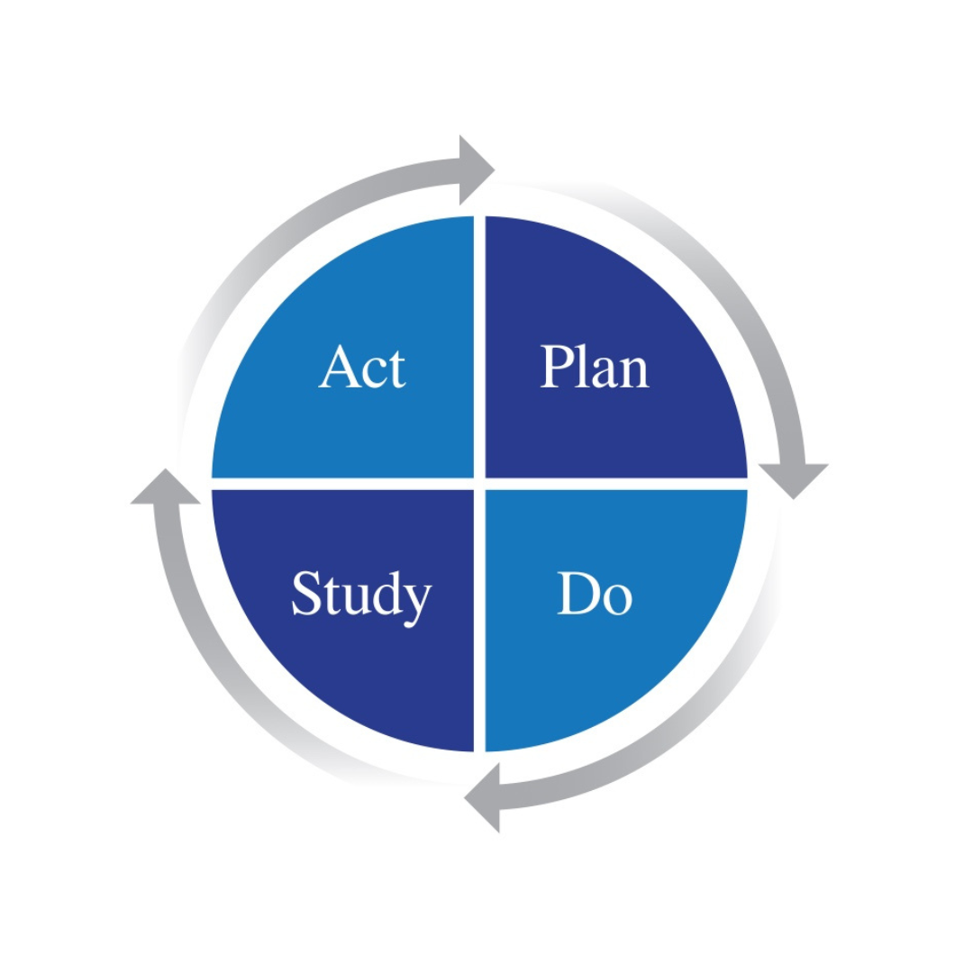

1. **Rapid-cycle problem-solving** is an improvement cycle that uses the Plan, Do, Study, Act Cycle process to make quick, incremental improvements. It is typically used to solve urgent problems that exist or emergent problems that arise when attempting to use an innovation for the first time.
2. **Usability testing** is used to test the feasibility and impact of a new way of work prior to attempting to use it more broadly. Usability testing consists of a planned series of tests of an innovation, components of an innovation, or implementation processes for improvement.
3. **Practice-policy feedback loops** are established to ensure that a) barriers to effective practice are brought to the attention of policy makers, b) sound policy that strengthens implementation is maintained, and c) transparent processes exist to support the development of policy enabled practices and practice informed policies. Improved system functioning is the result.
4. A **Transformation Zone** is a “vertical slice” of the system; small enough to be manageable and large enough to ‘disturb’ and impact key aspects of the system, yet not impact the entire system. The intention is to use the improvement cycles to develop the systems and infrastructure that will be needed for successful implementation, sustainability, and scale-up of effective education practices.

**Improvement Cycles Comparison**

|  |  |  |  |  |
| --- | --- | --- | --- | --- |
|  | **Focus** | **Primary Point of Application** | **Cycle Duration** | **Purposeful Use** |
| **PDSA Cycles: Rapid-Cycle Problem Solving** | Individual Practices | Initially identifying problems and solutions | Daily or weekly cycles | District Implementation Team |
| **Usability Testing: Developing Feasible Methods** | Groups of practices; operating methods | Testing the feasibility of solutions and developing administrative supports | Weekly or monthly cycles | District and Regional Implementation Teams |
| **Practice-Policy Communication Cycles: System Change** | Modification of units and relationships among units | Executive leadership and others with authority to change system units | Monthly or bimonthly cycles | Regional Implementation Team and State Transformation Specialists |

# Related Resource

* [Improvement Cycles Overview (Module 5)](https://implementation.fpg.unc.edu/resource/improvement-cycles-overview/) - Formally known as “modules” on the AI Hub, we have condensed the information into document overviews. As you begin your journey of implementation, take a moment to read and learn more about improvement cycles (PDSA).