Handout: Implementation Drivers
Implementation Drivers Overview
Implementation Drivers are the key components of capacity that facilitate the use of the program or practice and subsequent impact on students. Implementation Drivers assure development of relevant competencies, necessary organization supports, and engaged leadership.

Key Takeaways
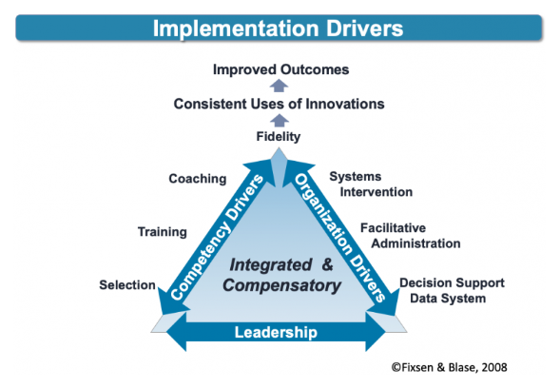
- There are 2 categories of Implementation Drivers:
  - Competency Drivers – are mechanisms to develop, improve and sustain one’s ability to implement an innovation as intended in order to benefit students.
  - Organization Drivers – are mechanisms to create and sustain hospitable organizational and system environments for effective educational services – that ‘enabling context’ we talked about earlier.
- Leadership – focus on providing the right leadership strategies for different types of leadership challenges. These leadership challenges often emerge as part of the change management process needed to make decisions, provide guidance, and support organization functioning.
- A key feature of Implementation Drivers is their integrated and compensatory nature:
  - Integration – means that the philosophy, goals, knowledge and skills related to the program or practice are consistently and thoughtfully expressed in each of the Implementation Drivers.
  - Compensatory – means that the skills and abilities not acquired or supported through one driver can be compensated for by the use of another driver.

Related Resources
- Implementation Drivers Overview (Module 2)
This overview of the Implementation Drivers is designed to help you think about developing and sustaining the infrastructure you need to improve and sustain new instructional practices and behavior supports so that academic and behavioral outcomes improve.
- Drivers Best Practices Assessment
Implementation Drivers are the key components of capacity and the infrastructure supports that enable a program’s success. This assessment tool can be used by Implementation Teams during any Implementation Stage to rate implementation supports currently in place.
- Strategic Analysis of the Implementation Drivers Worksheet
This planning tool assists Implementation Teams in exploring Implementation Drivers (competency, organizational and leadership), including Driver functions and accountability, as well as how each can be improved to better support implementation.
- Fixsen, D. L., Naoom, S. F., Blase, K. A., Friedman, R. M. & Wallace, F. (2005). Implementation Research: A Synthesis of the literature. The National Implementation Research Network.

