Activity: Implementation Drivers

EBP Drive Around
It is important to reflect on your learning of the implementation drivers within your own context. To assist with this reflection, you are going to “drive around” the implementation drivers utilizing a current program or practice you are implementing. Keep in mind that you may not have all of the drivers in place or that you may need to improve upon them. This activity will allow you to find the gaps in your implementation.

Instructions
- Jot down different EBPs/EIIs that you have experienced, participated in, or led.
- Pick one of those initiatives that has been in place for at least one year, and “drive around” the Implementation Drivers diagram below. Alone, or with your team, respond to the reflection questions.
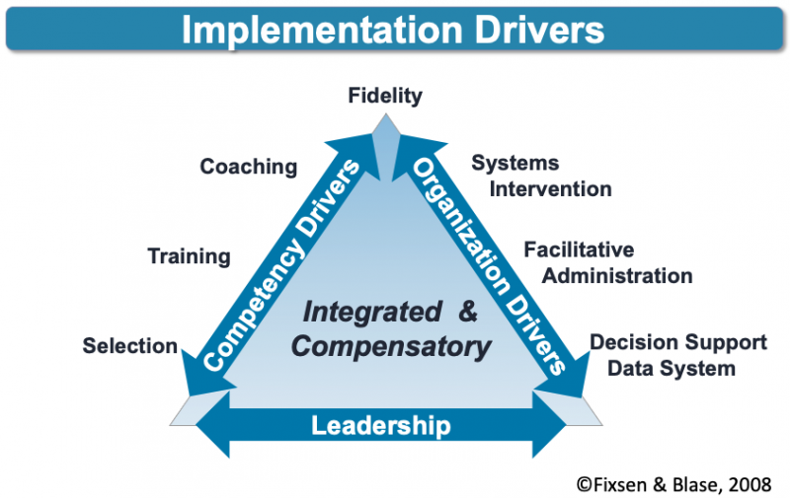

Reflection Questions
- Reliable Benefits / Consistent Uses of Innovations
How long has the EBP / EII been in place? How many students are benefitting? What data tell you they are benefitting?
- Performance Assessment
Are fidelity data available? If so, what data? Who has access to it? How is it used?
- Competency Drivers
Is timely and skill-based training and coaching available? How are new staff brought on board and how do they learn how to use the EBP/EII?
- Organization Drivers
Is there a team in place that focuses on the implementation process? Are they supported by the system? Has the work environment been adjusted (e.g., scheduling, materials, time) to support the use of the EBP / EII? Does the team use data to drive decision making?
- Leadership
How are challenges identified, addressed, and managed?

Next Steps
How did you do? Congratulations! You have just experienced just a few of the thought processes that occur during Implementation Team meetings! Might one of the teams be asking these same questions?

