Activity: Implementation Drivers

Mapping Feedback and Feed Forward Pathways
Integration of Implementation Drivers, including creating information / communication pathways, is a key facet of doing Active Implementation. Using the Implementation Drivers diagram, map your current, then improved information / communication pathways between Drivers. Then name three ways to get there.

Instructions
- Map your current feedback and feed forward processes
For example:
- If a Driver is connected to another Driver via an established information/communication protocol, draw an arrow from that Driver to the other Driver.
- If the information and communication process is a two-way flow, put arrows on both ends of the connector.
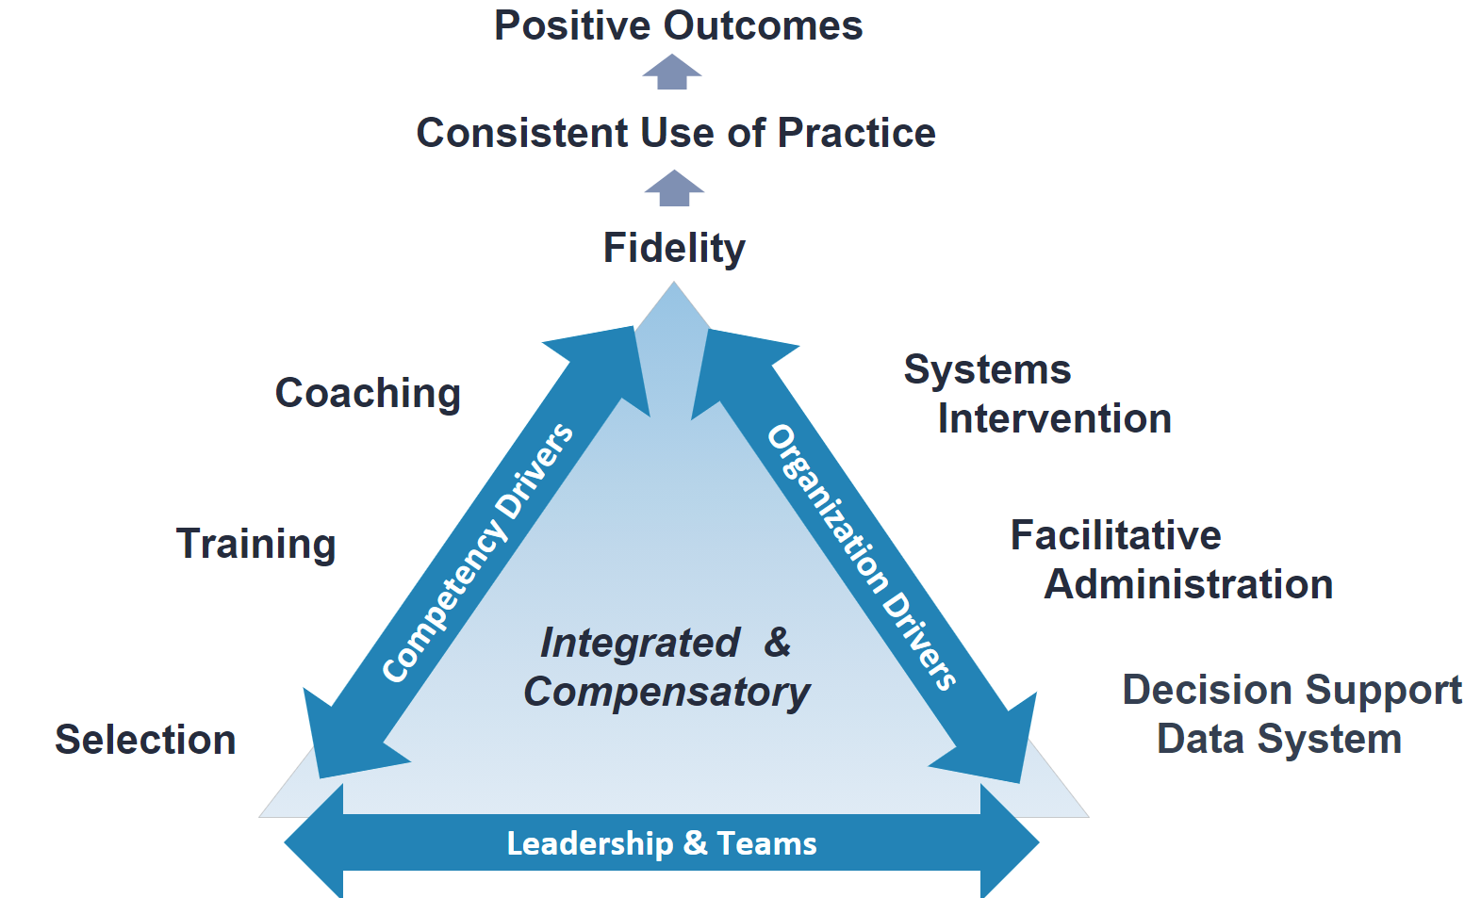
- Map your improved feedback and feed forward processes
Review your map from Part 1. Think about how a Driver can “feedback” information to another Driver to help improve Driver quality (e.g., training outcomes can inform selection protocols). Think about how each Driver can “feed forward” information to other Drivers to improve Driver quality (e.g., feed forward of training results to coaches to help coaches focus more quickly on certain skills).
For example:
- How could new information and communication pathways be created?
- How might one-way flows be converted to two-way flows?

- Apply It Now
What are three things you could do to improve (integrate) feedback and feed forward processes (e.g., information / communication pathways) between Drivers in your current setting?
Table 1. Action Plan
Action | Goal / Purpose | Lead

