Activity: Implementation Drivers

Locus of Responsibility
To what degree do you have control and responsibility over Implementation Driver resources, personnel, or processes? The purpose of this activity is to help you quickly assess locus of responsibility in your system, then develop action plans to improve the quality, access, and integration of Implementation Drivers.

Instructions
- Map your current locus of responsibility
- Select an existing program, practice, or innovation in your system / organization.
- For each Implementation Driver, indicate if your team has:
  - Direct Control-draw a solid circle around the Driver
  - Influence-draw a dashed circle around the Driver
  - No control-draw a square around the Driver
  - If the Driver does not exist, draw an “X” through it
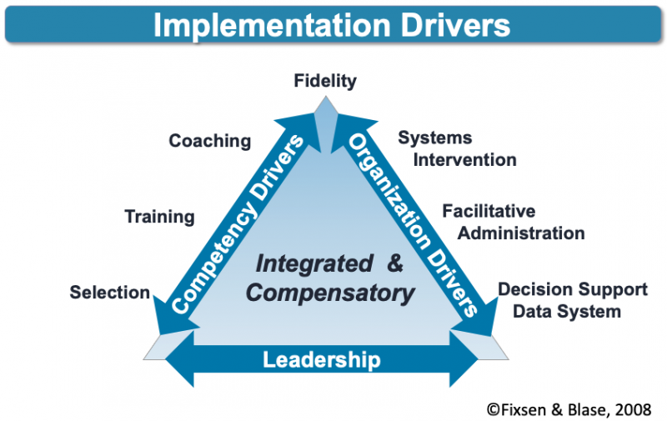
- Review and Reflect
Review your locus of responsibility map.
- Which Drivers can be improved in terms of access and quality because you have responsibility for them?
- Which Drivers might you influence through feedback, collaboration, and use of data?
- Are you clear about who is responsible for each Drivers?
- How might you ensure integration of the Drivers if different entities have responsibility?

- Apply It Now
- What are three things you could do to improve Drivers for which you have responsibility?
- What is one thing you can do to improve a Driver for which you have influence?
- Do you need an action plan to ‘activate’ one of the Drivers? If so, what is an action step you can take?

Has influence and can provide feedback, purchase, negotiate, but does not have direct control
Has no control or influence over timing, quality, personnel and not opportunity to influence
Has no knowledge that the Driver exists at this point in time (e.g., not activated)

